How to create UI
Create Container Instances
- Opend AB Tool then click RepClass
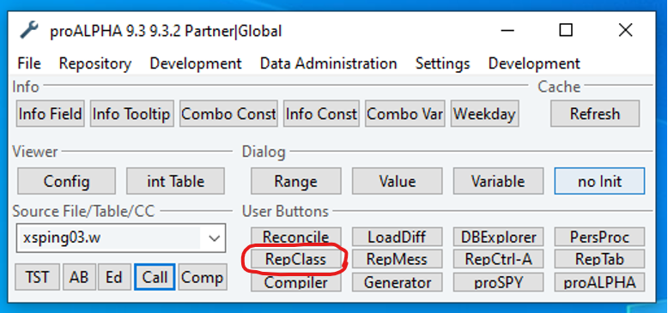ptest
- Serch s_part00.w to find Master Data then press ‘tab’, then press ‘enter’
(‘p’ means container)
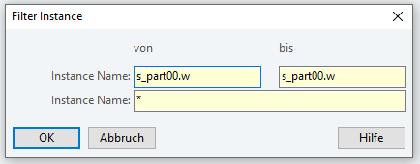
- Find ‘Master Data Maintenance’ then Right click on it and click ‘Instances’.
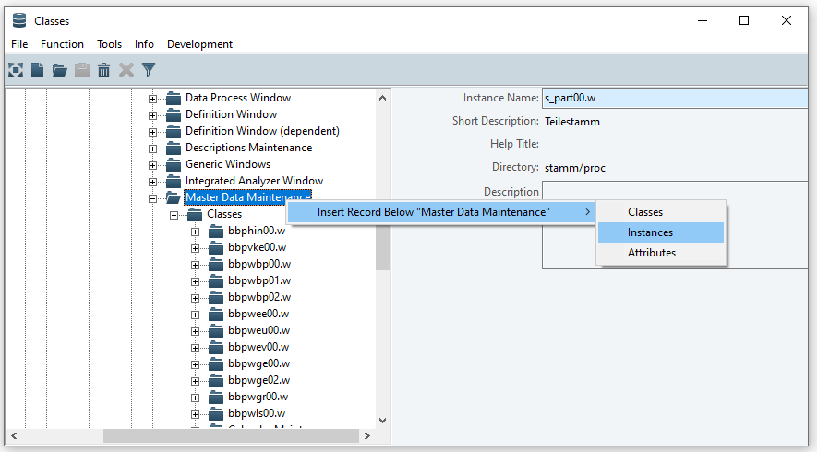
- Name your Instances then save
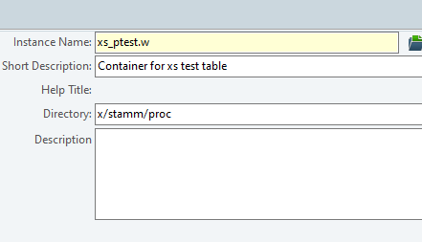

Create Viewer Instances
- Find ‘SmartViewer’ then Right click on it and click ‘Instances’
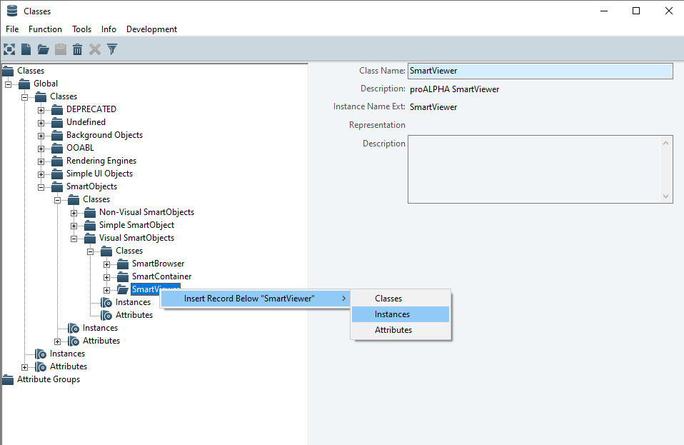
- Name your Instances then save
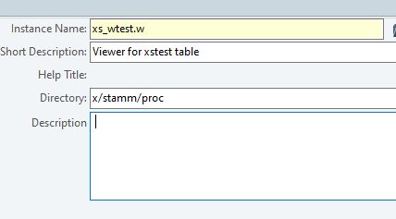

Create Browser Instances
- Find ‘SmartBrowser then Right click on it and click ‘Instances’
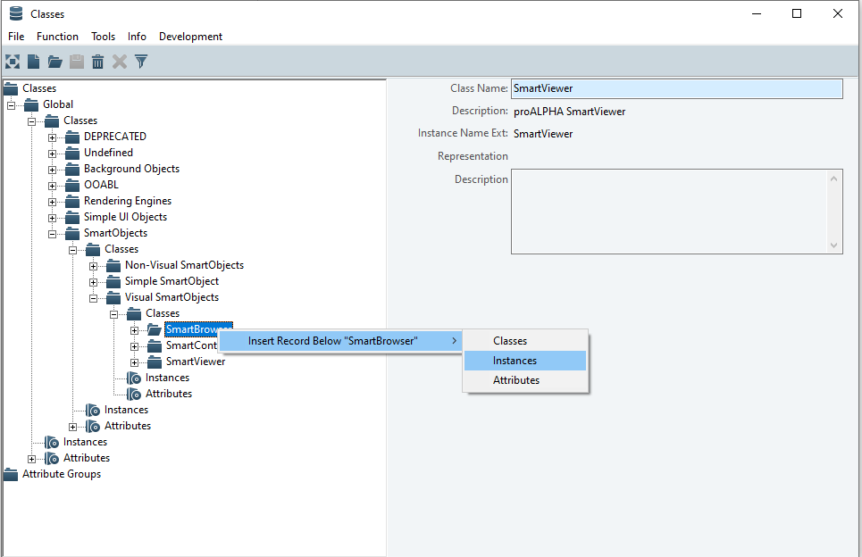
- Name your Instances then save
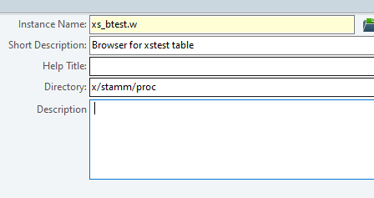

Create Query Instances
- Click on search fliter
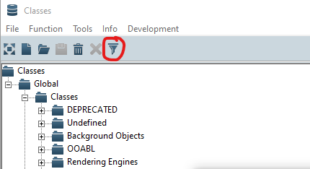
- Serch s_qart00.p to find SmartQurey then press ‘tab’, then press ‘enter’
(‘p’ means container)
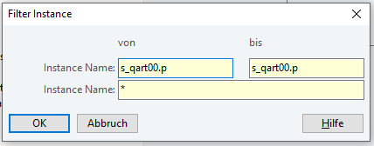
- Find ‘SmartQuery then Right click on it and click ‘Instances’
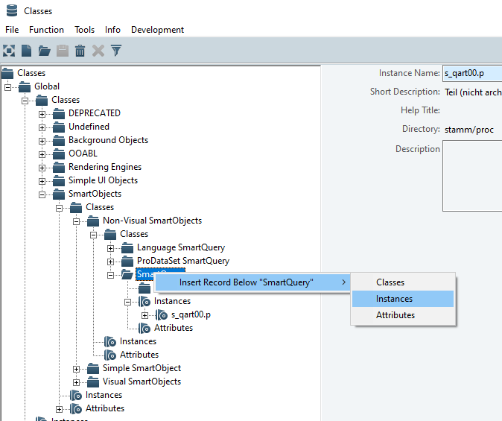
- Name your Instances then save
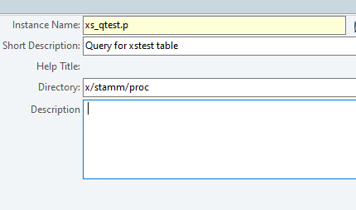

Create UI
Create Viewer
- Open AB Tool then Click Flie >> New
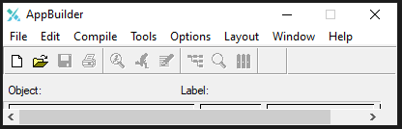
- Find proALPHA SmartViewer then click OK
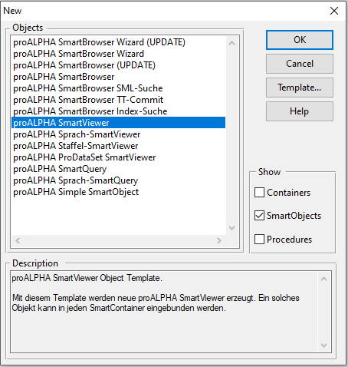

- Select table
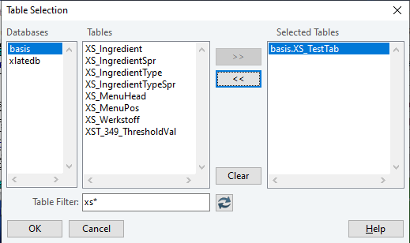
- Seclect column to show on viewer
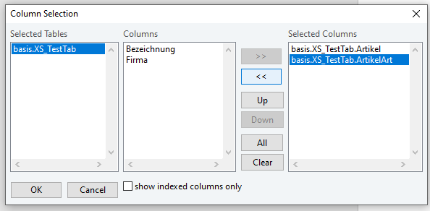

- Double click Fill
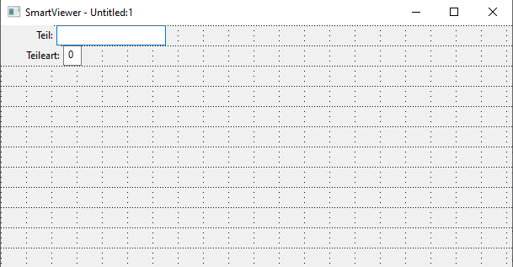
- Set Column (21 is default for praALPHA) then ok and save
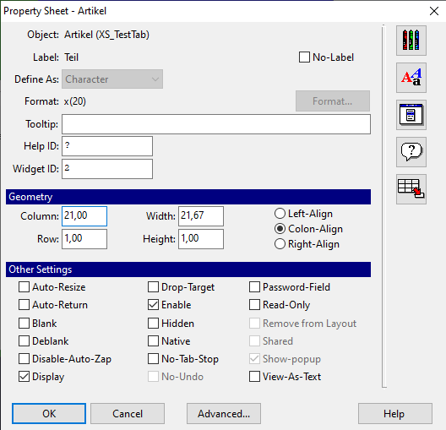
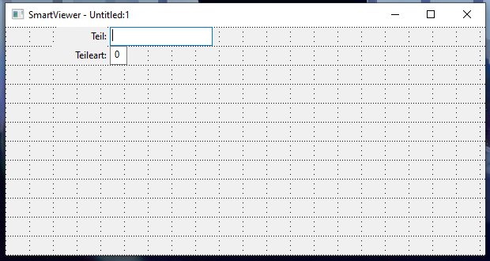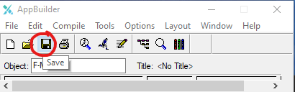
Create Container
- Open AB Tool
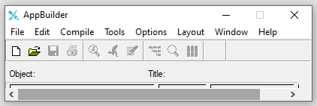
- Click on File >> New >> proALPHA SmartWindow then click OK.
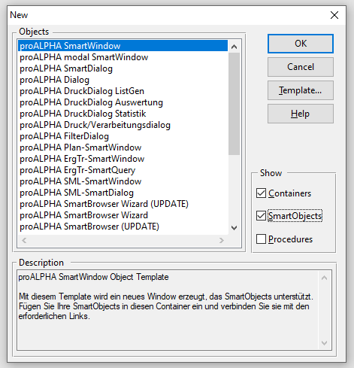

- Name your container then OK
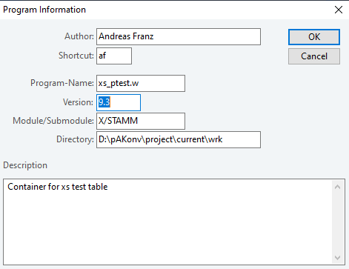
- Done you can shift + Backspace to delete instanecs then save
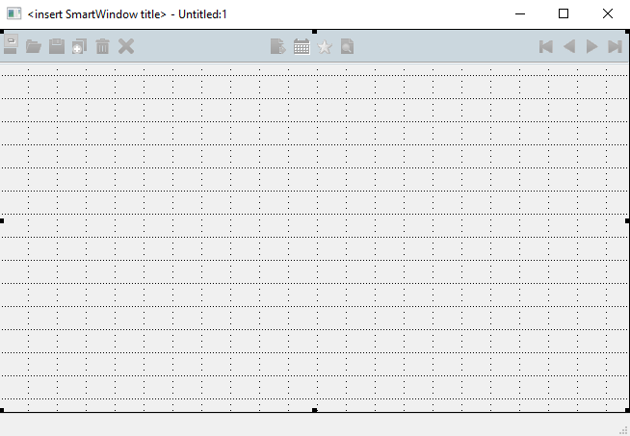

- Choose Continue. Save the flie anyway and click OK
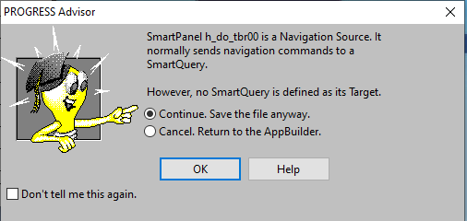

Create Query
- Open AB Tool

- Click on File >> New >> proALPHA SmartQuery then click OK.
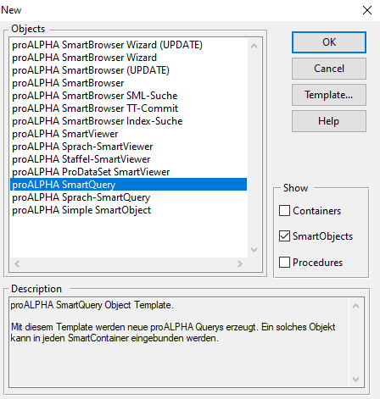
- Name your Query then OK
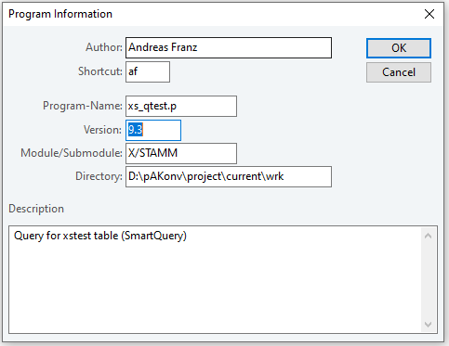
- Skip page 1-2 then Defind Query
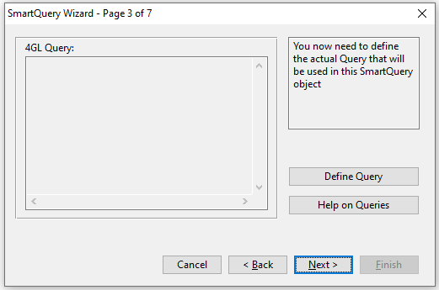

- Find XS_TestTab then Add and click Where
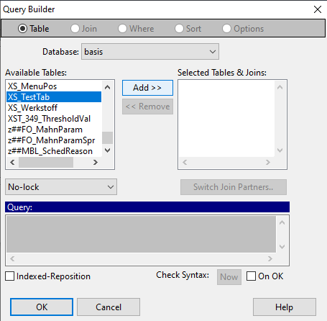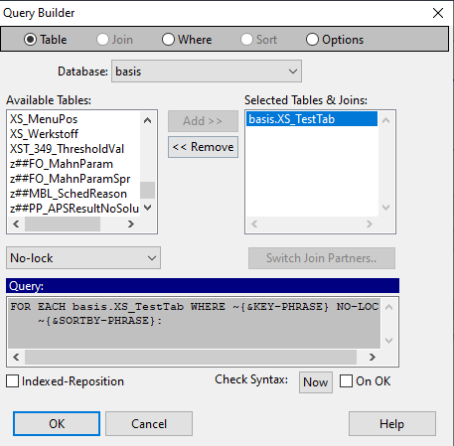
- Choose Firma and click =
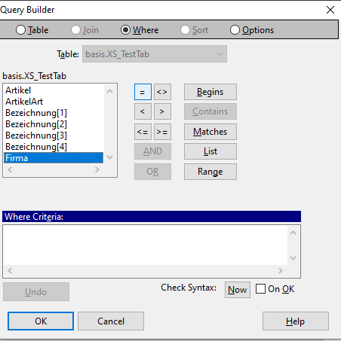
- Click OK without enter value
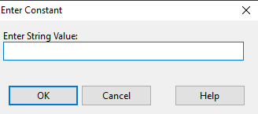

- ‘pa2’ in codev and spacebar then fill in where firma
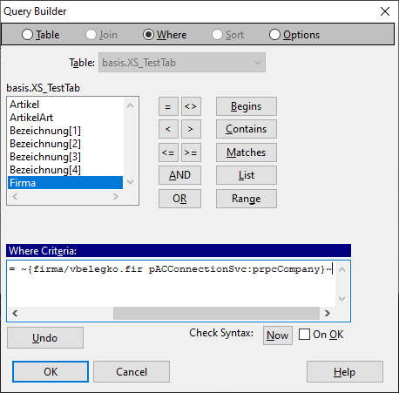
- Defind Foreign Keys
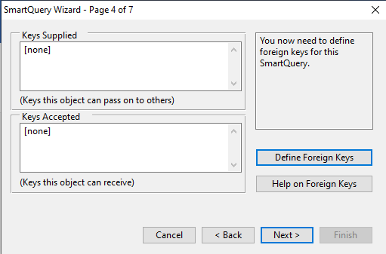
- Click Insert Aindex then OK
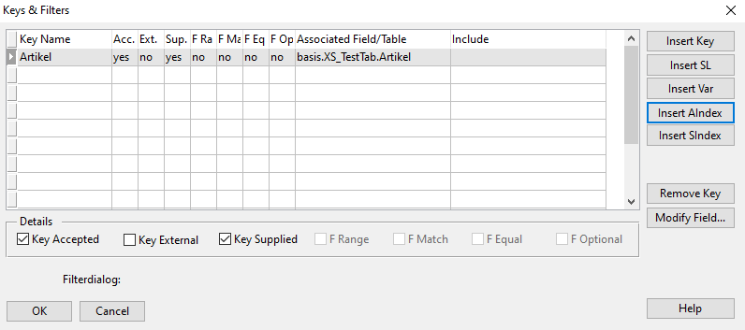
- Defind Sort Cases
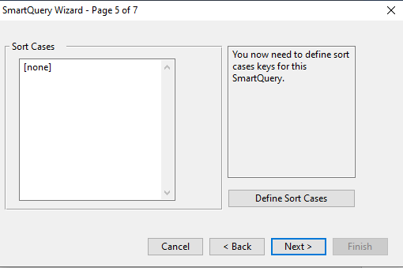
- Click Quick Insert and choose Sort case then OK
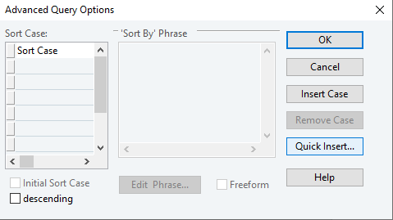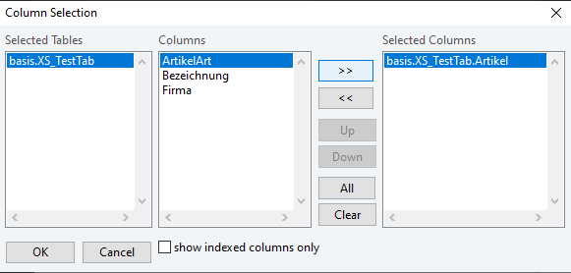

- Next and finish you will see Query then Save
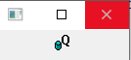
Create Browser
- Open AB Tool

- Click on File >> New >> proALPHA SmartQuery then click OK.
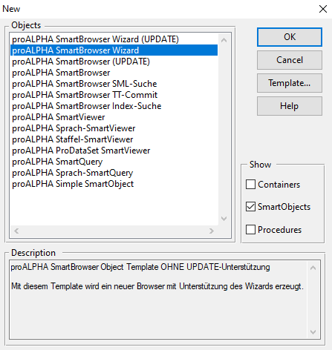

- Name you Browser then click OK
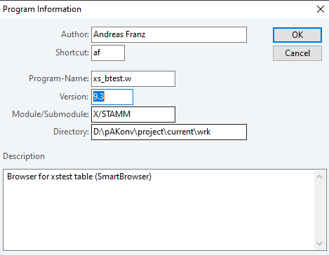
- Skip page 1-2 then Defind Query
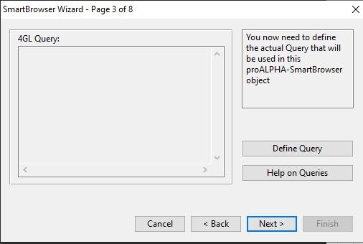
- Find XS_TestTab then Add and click Where
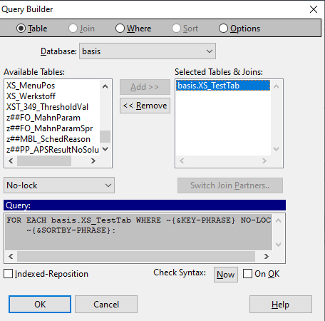
- Choose Firma and click =

- Click OK without enter value

- ‘pa2’ in codev and spacebar then fill in where firma

- Defind sort case
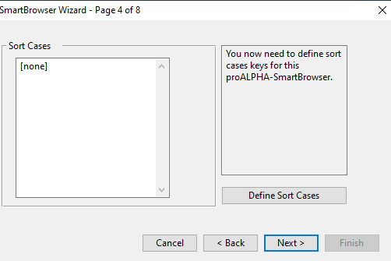
- Click Quick insert and choose sort case then click OK
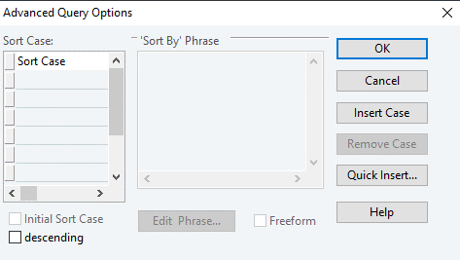
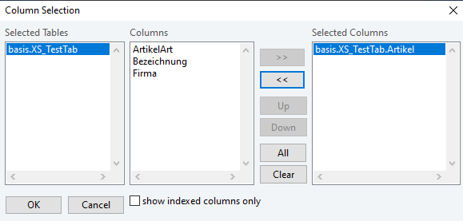

- Add fieds
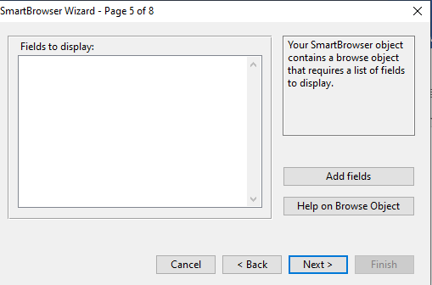
- Add fields you want to show **Check enable the last fields**
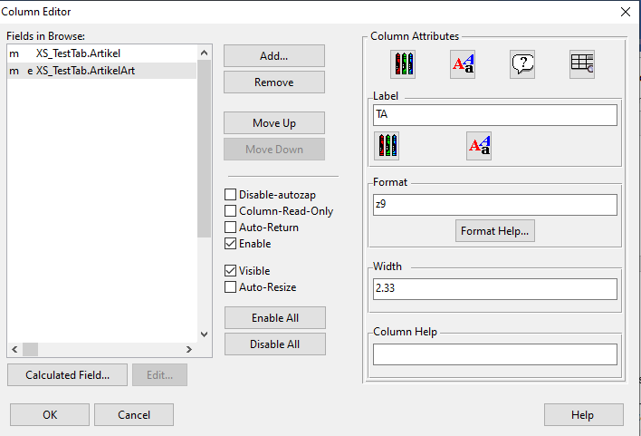

- Defind Foreign Keys
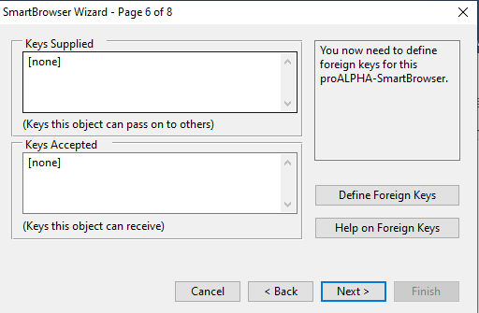
- Click Insert Sindex then OK
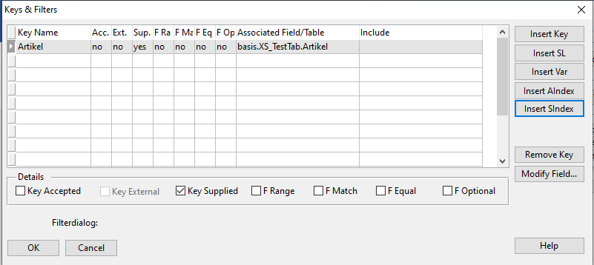
- Update Query
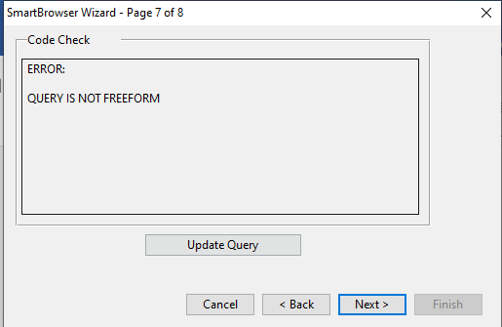
- Freeform Query
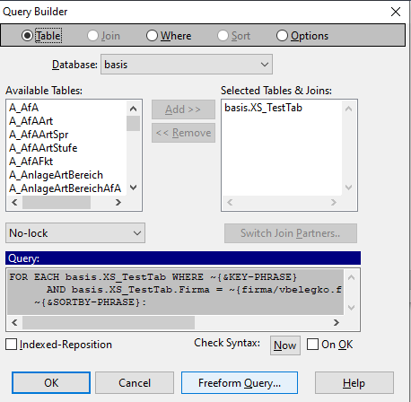
- Freeform. Allo freeform editing of query the OK
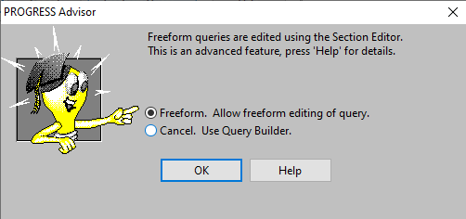
- Next and finish you will see Browser then save
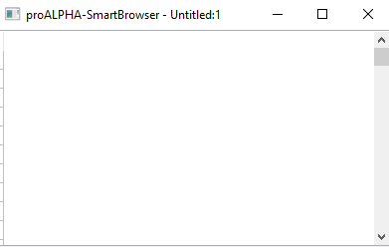

How to add Viewer, Query, Browser to Container
Viewer to Container
- Open your Container by fill in Sourc File then click AB
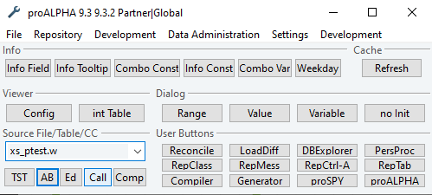
- Click SmartViewer icon in palette
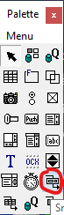
- Click Browse and choose flie viewer
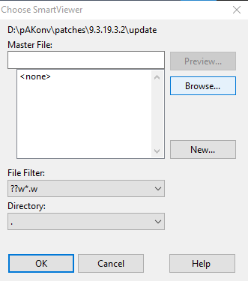
- Click on Container to paste viewer and Add. Create link from SmartPanel then OK
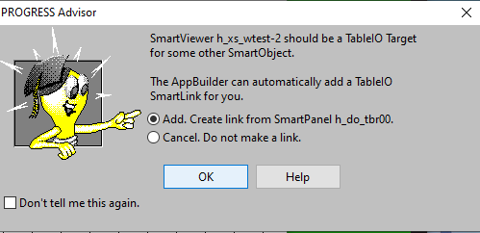
- Save
Query to Container
- Open your Container by fill in Sourc File then click AB

- Click SmartQuery icon in palette
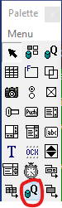

- Browse and choose Query file
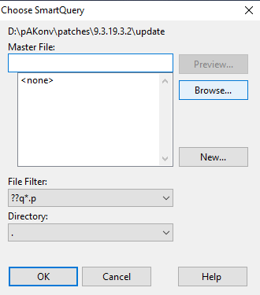
- Click on Container to paste viewer and Add. Create link from SmartPanel then OK and save
Browser to Container
- Open your Container by fill in Sourc File then click AB

- Click SmarBrowser icon in palette
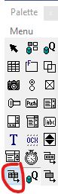
- Browse and choose Browser file
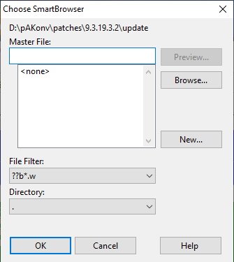
- Click on Container to paste viewer and Add. Create link from SmartPanel then OK and save

Menu Designer
- Call container you want to add menu
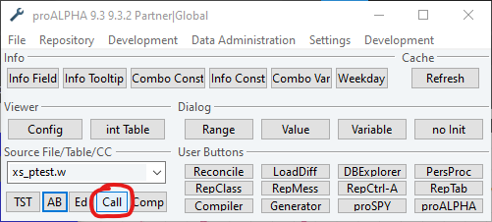
- Click Development then Menu Designer
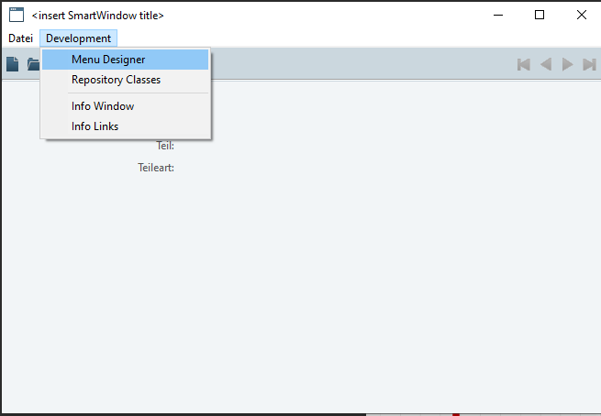
- Click create
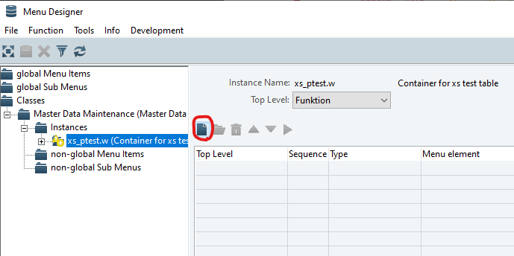
- Click Non-Global Menu Item then OK
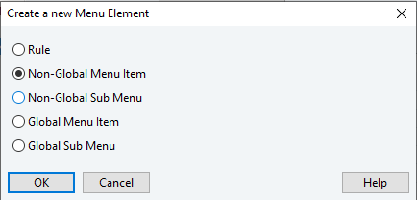
- Name your fuction and menu name
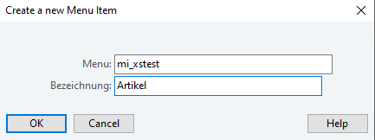
- Double click on function then click parameter
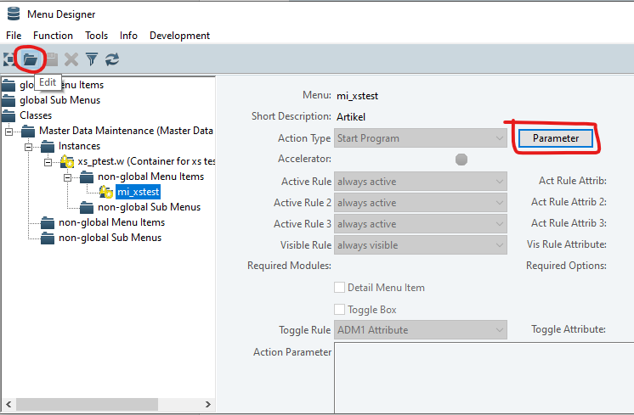

- Choose Instance you want to show next page
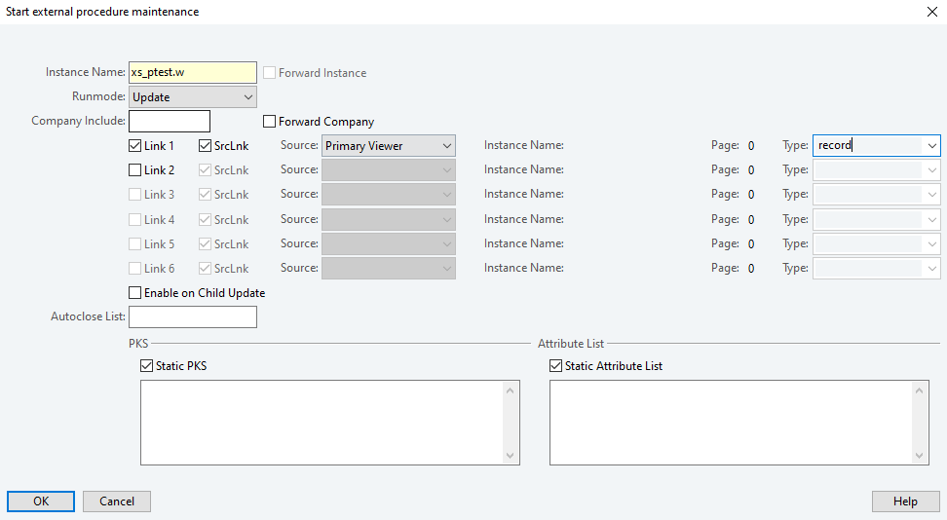
- Save
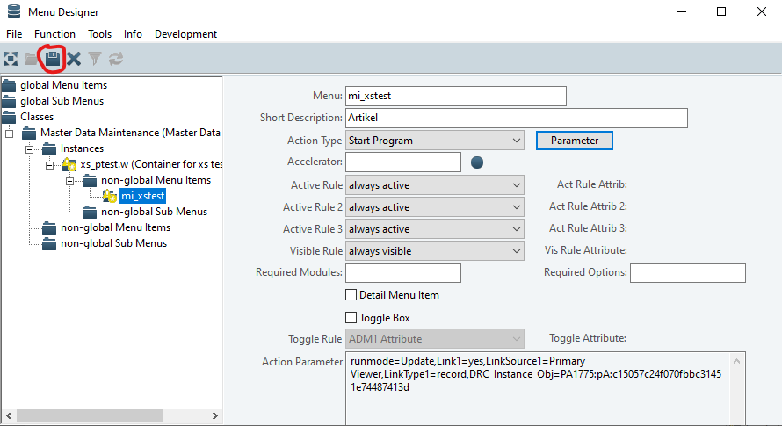

- Now you will see Function
